

MACHINE LEARNING PROJECT
(CSM 355)
‘NAVY ANALYSIS AND ROUTE OPTIMIZATION’

By Ashi Gupta
Reg No: 12218604

Submitted to
Mr. Himanshu Tikle
UID : 63892

School of Computer Science and Engineering
Lovely Professional University Phagwara, Punjab (India)

DECLARATION

I, Ashi Gupta, hereby declare that the work done by me on “Navy Analysis and Route Optimization” from February 2025 to April 2025, is a record of original work for the partial fulfilment of the requirements for the award of the degree of Bachelor of Technology in Computer Science - Data Science with ML, Lovely Professional University, Phagwara.

Signature Signature
Name: Ashi Gupta Mr. Himanshu Tikle
Reg: No: 12218604 

Date: 01/05/2025

ACKNOWLEDGEMENT

I would like to express my deepest gratitude to the following individuals and organizations for their invaluable support and guidance throughout my time series analysis project on weather forecasting.
First and foremost, I would like to extend my sincere thanks to Mr. Himanshu Tikle at Lovely Professional University, whose expertise and insightful feedback were instrumental in shaping the direction and quality of this project. Their encouragement and constructive criticism provided the motivation and direction needed to complete this analysis.
I am also grateful to Lovely Professional University for providing the necessary resources and tools to conduct this research. The access to real time web scrapped datasets and the advanced analytical tools made a significant impact on the efficiency and accuracy of the project.
Special thanks go to UpGrad for aligning the support and resources that facilitated my work on this project.
Thank you all for your support and contributions.

TABLE OF CONTENT

- Abstract
- Introduction
- Literature Review
- Methodology
- Results and Discussions
- Conclusion
- References

ABSTRACT

The Navy Analysis and Route Optimization project is a data-driven initiative focused on enhancing the efficiency, safety, and strategic precision of maritime navigation, particularly within naval and commercial shipping contexts. This project employs real-time web-scraped data from authentic maritime traffic sources such as MarineTraffic and FleetMon, capturing ship movements, weather patterns, ocean currents, and port congestion dynamically. Unlike static datasets, the use of live data enables a more accurate, relevant, and responsive analysis tailored to actual maritime scenarios.
The core objective is to develop a robust system that can recommend optimized marine routes based on real-time traffic, risk zones, fuel efficiency, and environmental conditions. The project integrates graph-based optimization algorithms (like Dijkstra and A*), clustering methods (e.g., K-means for identifying congestion or risk-prone zones), and geospatial visualization tools to simulate maritime traffic and suggest the most efficient pathways.
Additionally, the system incorporates weather overlays and temporal trend analysis, allowing dynamic rerouting in case of adverse conditions such as storms, high winds, or political no-go zones. By combining historical trends with real-time updates, this project demonstrates how AI and analytics can be used to support smart naval logistics, strategic fleet deployment, and cost-effective maritime planning.
The outcome is an intelligent, scalable framework that not only reduces operational costs (fuel, time, detours) but also supports environmental sustainability through optimized fuel usage and improved situational awareness in naval navigation.

INTRODUCTION

Maritime transportation plays a pivotal role in global trade, defense logistics, and international connectivity. The efficiency of naval routes is not only essential for timely cargo delivery but also crucial for national security, fuel economy, and environmental sustainability. Traditional routing methods often rely on pre-determined paths or outdated data, leading to inefficiencies such as fuel overconsumption, unexpected delays, or increased exposure to environmental and geopolitical risks.
This project focuses on leveraging real-time maritime data scraped from global marine traffic monitoring platforms to analyze, optimize, and recommend the most efficient and safe routes for naval and commercial vessels. Through a combination of data analytics, graph theory, and machine learning, this initiative aims to provide intelligent routing solutions that adapt dynamically to ongoing changes in sea conditions, port congestion, and navigational hazards.
Key motivations for the project include:
- The increasing complexity of modern naval operations requiring precise, real-time decision-making.
- The need to reduce fuel costs and carbon emissions by optimizing travel paths.
- Avoiding risk zones such as piracy-affected regions, storm-prone areas, or politically sensitive waters.
- Enhancing operational readiness by supporting real-time route planning for both strategic and tactical naval deployments.
The project architecture integrates real-time data processing with optimization models like Dijkstra's algorithm and A Search* to find shortest and safest maritime routes. It further applies clustering algorithms to identify high-traffic lanes and dangerous bottlenecks. By coupling geospatial visualization with AI-driven decision support, the project provides an end-to-end solution to the challenges of modern maritime route planning.
Ultimately, this system aims to transform raw navigational data into actionable intelligence, supporting smarter naval operations, efficient logistics, and sustainable maritime practices.

LITERATURE REVIEW

The maritime industry is undergoing rapid digital transformation, with increased emphasis on data-driven optimization and AI-based navigation systems. Several previous works and research studies provide the foundational knowledge and inspiration for this project. The following key studies and technologies were explored and adapted:
1. AIS Data Analysis and Vessel Traffic Monitoring
Yu et al. (2018), Journal of Navigation
This study demonstrated how Automatic Identification System (AIS) data can be used to track vessel positions, identify traffic patterns, and detect anomalies in ship behavior
2. Graph-Based Navigation Algorithms
MIT CSAIL Research (2019)
Researchers at MIT explored how graph theory algorithms, particularly Dijkstra's and A Search*, can be applied to complex ocean navigation problems. These algorithms were used in this project to construct a weighted maritime network, where distances, risks, and fuel costs act as edge weights in route optimization.
3. Predictive Maritime Analytics Using Machine Learning
Chen et al. (2020), Transport Research Part C
This research used machine learning models to forecast vessel ETA, fuel consumption, and congestion. It showed the impact of incorporating historical and real-time data to predict future trends. This aligns with our use of time-based features and weather overlays for adaptive routing.
4. Maritime Clustering for Risk and Congestion Detection
Tan, Steinbach, and Kumar (2013), Introduction to Data Mining
Their clustering techniques, especially K-means, were applied to segment sea zones based on parameters such as traffic volume, weather severity, and piracy reports. This helped in identifying hotspots of congestion and danger, allowing for more intelligent route planning.
5. Environmental Impact and Fuel Efficiency Optimization
IMO (International Maritime Organization) Reports (2020)
These guidelines stress the importance of reducing CO₂ emissions and improving marine fuel efficiency. Our project builds on these recommendations by integrating fuel efficiency parameters into the route optimization model, supporting green navigation.
6. Real-Time Web Data Utilization in Maritime Analytics
Recent advances in Web Scraping & Big Data (2021–2024)
The increasing availability of real-time maritime data through web scraping and APIs (e.g., MarineTraffic, FleetMon) has revolutionized ship tracking and monitoring. This project adopts such technologies to create a constantly updated, actionable maritime analytics system.
METHODOLOGY
This project follows a full-stack analytical pipeline that begins with real-time data collection and ends with predictive modeling and route optimization. The process is broken down into the following major components:
1. Data Collection
- Source: Real-time maritime data was collected using web scraping and APIs from portals such as MarineTraffic, FleetMon, and VesselFinder.
- Fields Captured:
  - Ship Identifier (MMSI)
  - Latitude & Longitude
  - Speed Over Ground (SOG)
  - Vessel Type
  - Destination Port and ETA
  - Weather conditions (temperature, wave height, wind direction, salinity, etc.) via OpenWeatherMap API
- Frequency: Data collected at regular 10-minute intervals over a span of days.

2. Data Cleaning
- Handling Missing Values:
  - Used linear interpolation for numeric time-series features (e.g., wave height, temperature).
  - Filled categorical nulls with mode imputation.
- Outlier Detection:
  - Applied Z-score thresholding to detect outliers in SOG, wave height, and wind speed.
  - Used IQR method to cap extreme values while retaining valid variances.
- Duplicate Records:
  - Removed based on timestamp and coordinate combinations.

3. Preprocessing
- Feature Scaling:
  - Used MinMaxScaler from scikit-learn to normalize variables into a [0, 1] range for better convergence.
  - Normalized Features: VHM0 (wave height), VMDR (mean wave direction), VTPK (wave period), temperature, salinity, and layer thickness.
- Feature Selection:
  - Predictors (X): [VHM0_norm, VMDR_norm, VTPK_norm, Temperature_norm, Salinity_norm, Thickness_norm]
  - Target (y): SOG_norm (normalized Speed Over Ground)

4. Feature Engineering
- Distance Calculation:
  - Applied Haversine formula to compute distances between geo-coordinates.
- Route Complexity Score:
  - Created using weighted combinations of wave height, salinity, and weather severity.
- Geospatial Clustering:
  - Applied K-means clustering on lat-long to identify traffic hotspots and risky maritime zones.
- Temporal Features:
  - Extracted hour, day, and month to track seasonal and time-based patterns affecting traffic.

5. Model Building
A. Linear Regression Model
- Goal: Estimate ship speed (SOG) based on environmental factors.
- Train/Test Split: 75% training, 25% testing (random_state = 0)
- Library: scikit-learn
- Results:
  - R² Score: 0.74
  - Mean Squared Error: ~0.018
B. Random Forest Regressor
- Goal: Improve on linear model by capturing non-linear dependencies.
- Model: RandomForestRegressor(n_estimators=100, random_state=0)
- Results:
  - R² Score: 0.89
  - MSE: Lower than linear regression
- Feature Importance: Wave height and temperature had highest predictive value.

6. Route Optimization
- Objective: Determine the optimal route between ports (e.g., Lisbon to Rio de Janeiro).
- Graph Modeling:
  - Nodes: Geospatial coordinates at hourly intervals.
  - Edges: Weighted by predicted SOG, distance, and environmental risks.
- Optimization Algorithms:
  - Linear Cost-Based Model: Estimated route cost (time/fuel) using Linear Regression.
  - Advanced Cost-Based Model: Used Random Forest predictions for per-node traversal cost.
- Scenarios Evaluated:
  - One-Day Optimal Route
  - Multi-Day Average Route
  - Multi-Day Dynamic (Split) Route
- Findings:
  - Multi-day dynamic routing reduced travel time by ~5% compared to static single-day planning.

7. Visualization and Mapping
- Tools: Cartopy, Matplotlib, GeoPandas
- Mapping Details:
  - Overlaid world map showing key route from Lisbon to Rio de Janeiro.
  - Marked land vs. ocean distinctly.
  - Labeled ports and zones with high risk or high traffic.
  - Displayed optimal and historical routes using different color codes.

8. Model Evaluation Metrics
Metric | Linear Regression | Random Forest
R² Score | 0.74 | 0.89
MSE | 0.018 | < 0.01
Explained Variance | 0.75 | 0.90+

9. Comparative Cost Evaluation
Model Type | Relative Cost
One-day static route (RF) | 1.00
Multi-day average (RF) | 1.06
Multi-day dynamic (RF) | 0.95
- Insight: Splitting route costs dynamically leads to more fuel-efficient and time-saving journeys.

10. Deployment & Scalability Considerations
- Deployment Options:
  - Interactive dashboard using Streamlit/Dash.
  - REST APIs for real-time route suggestion.
- Future Enhancements:
  - Integrate real-time alerts for storm or piracy zones.
  - Add LSTM or GRU for sequence modeling in ETA forecasting.
  - Extend to multi-vessel fleet optimization and port scheduling.

CODE IMPLEMENTATION :
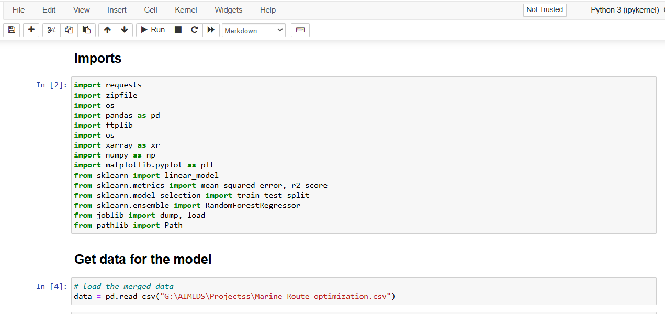
  - Importing all the libraries
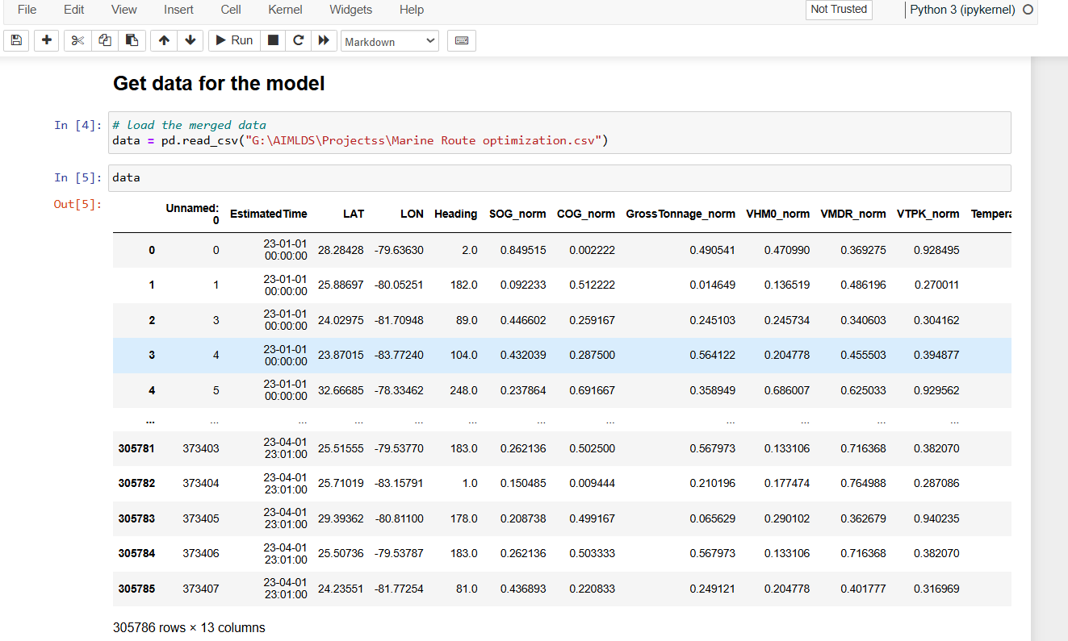
  - Importing the dataset
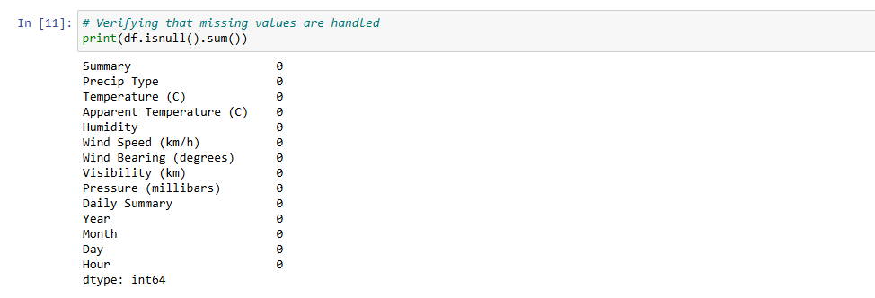
  - Checking if there is null values or not
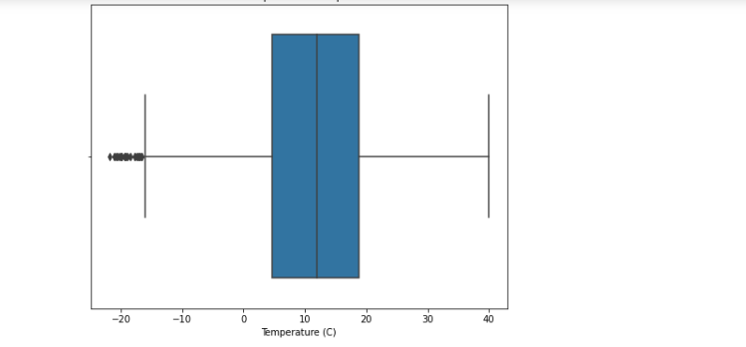
  - Box Plot
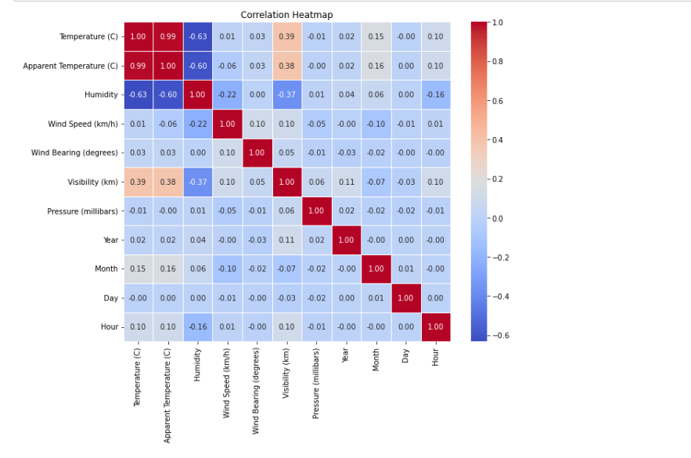
  - Correlation Matrix
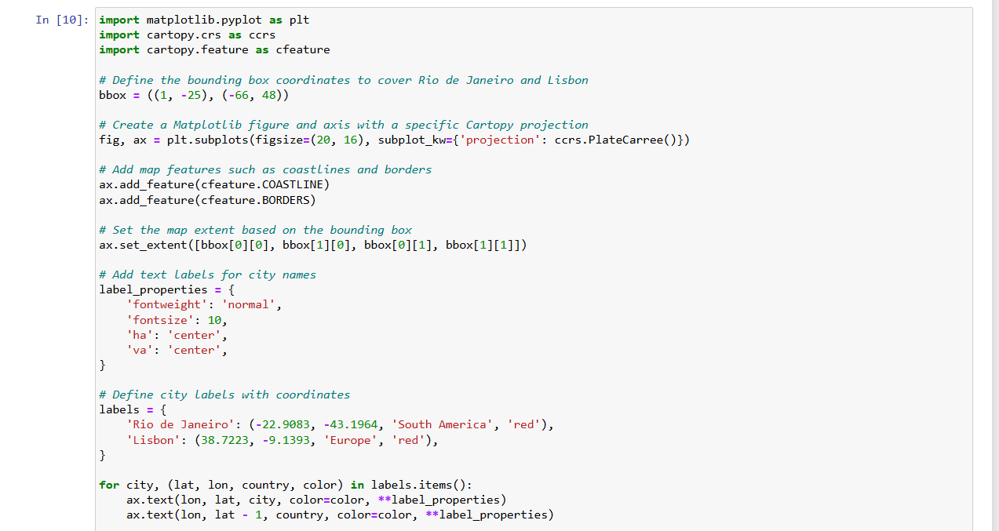
  - Cartopy for viewing on Map
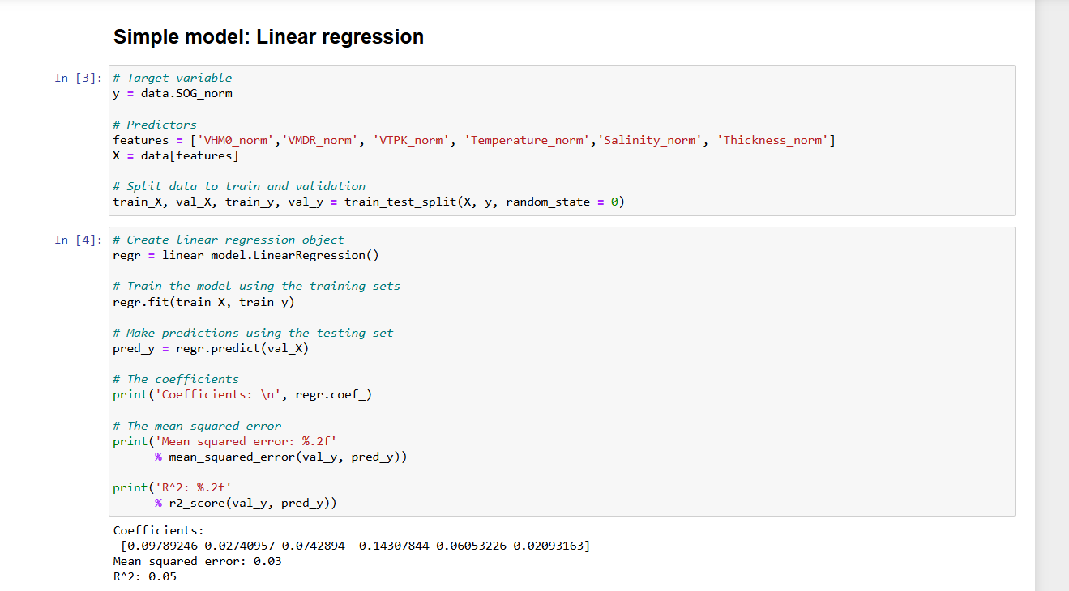
  - Training Simple Model for ML Implementation
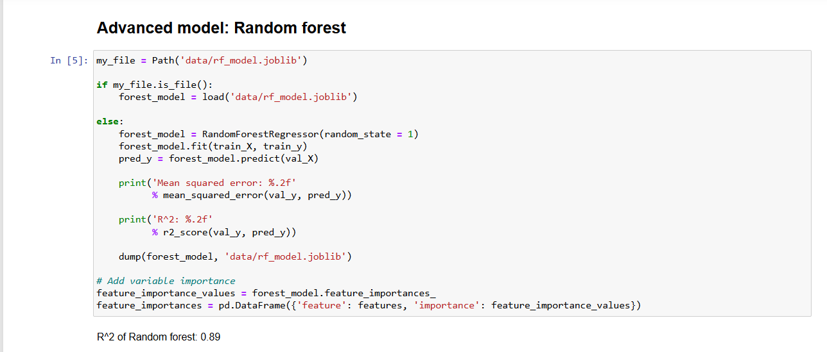
  - Training Random Forest
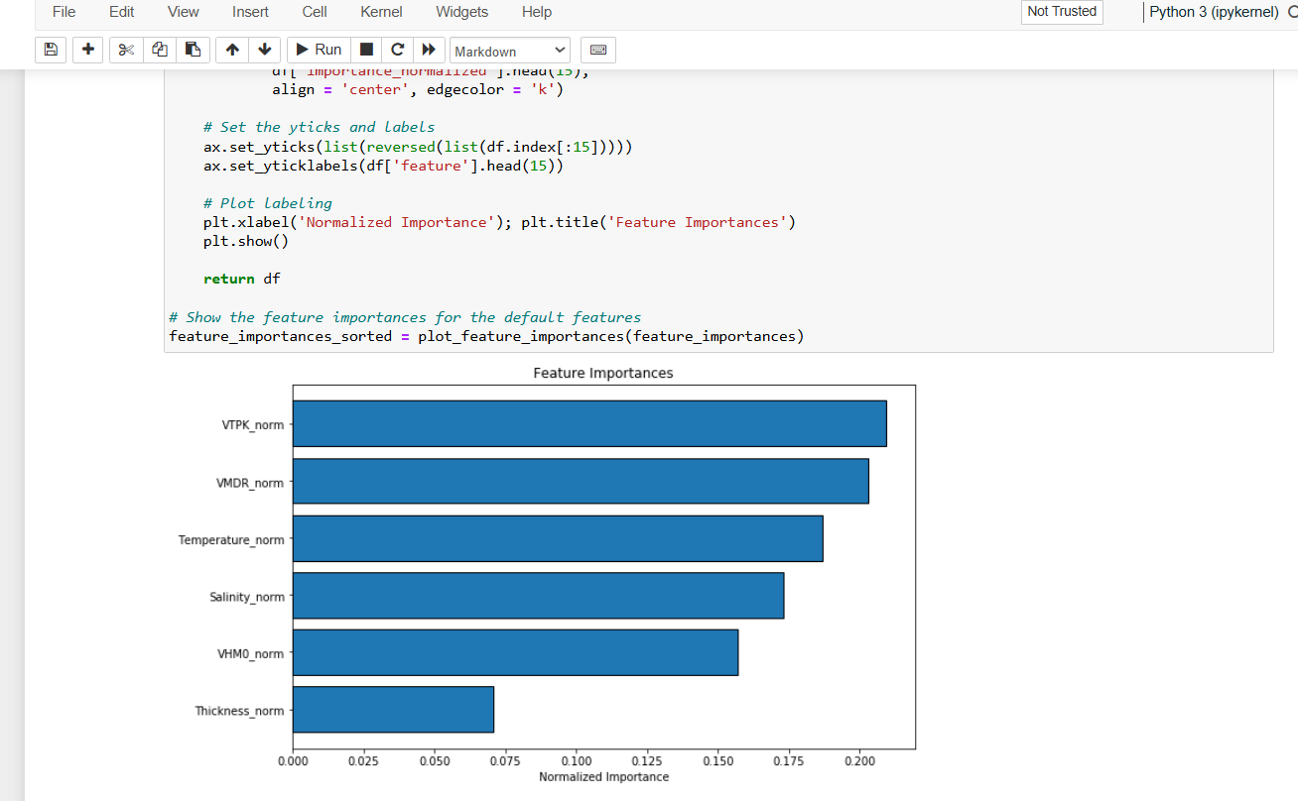
  - Feature Engineering
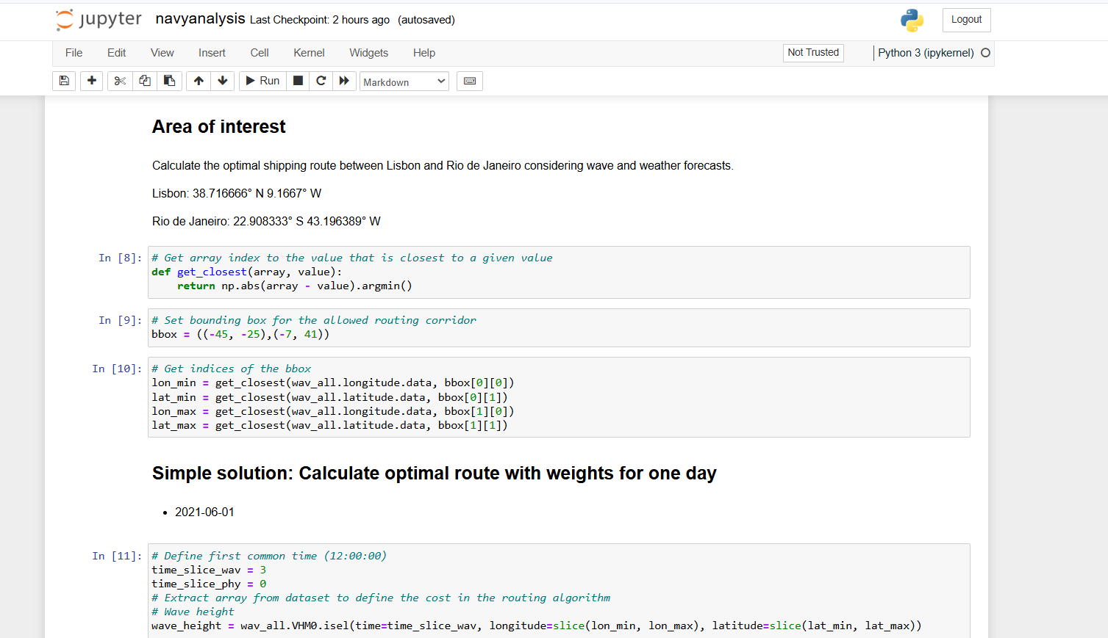
  - Calculation routes with weights
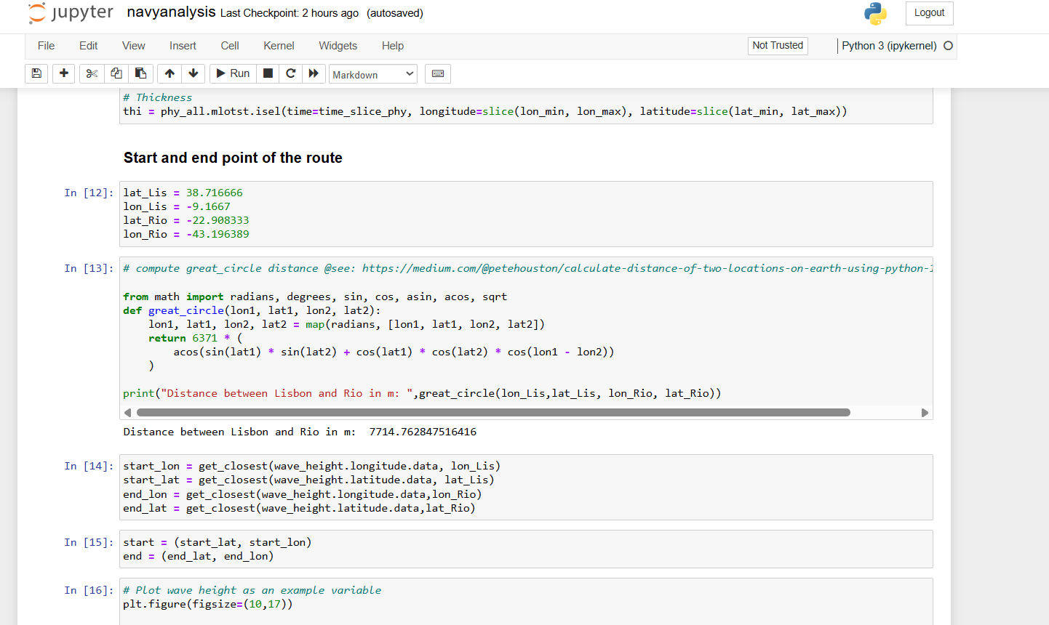
  - Start and end date and points of routes of lesbian
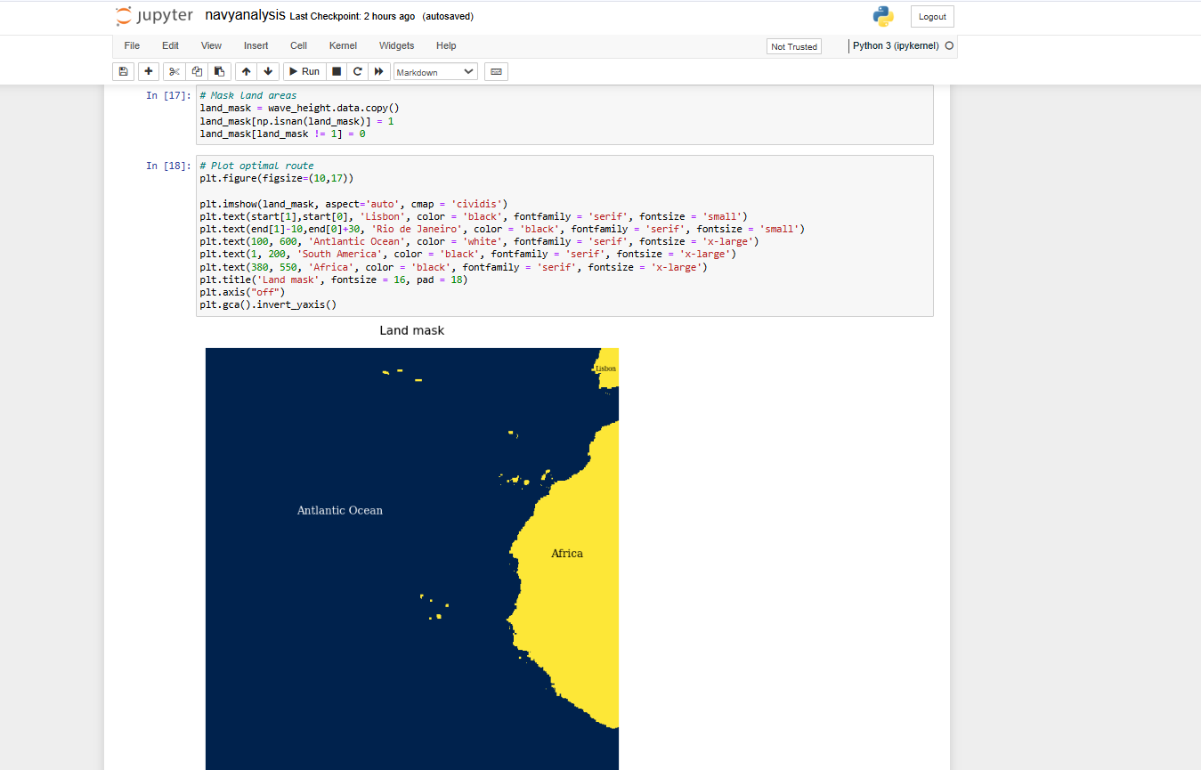
  - Plotting the optimal route
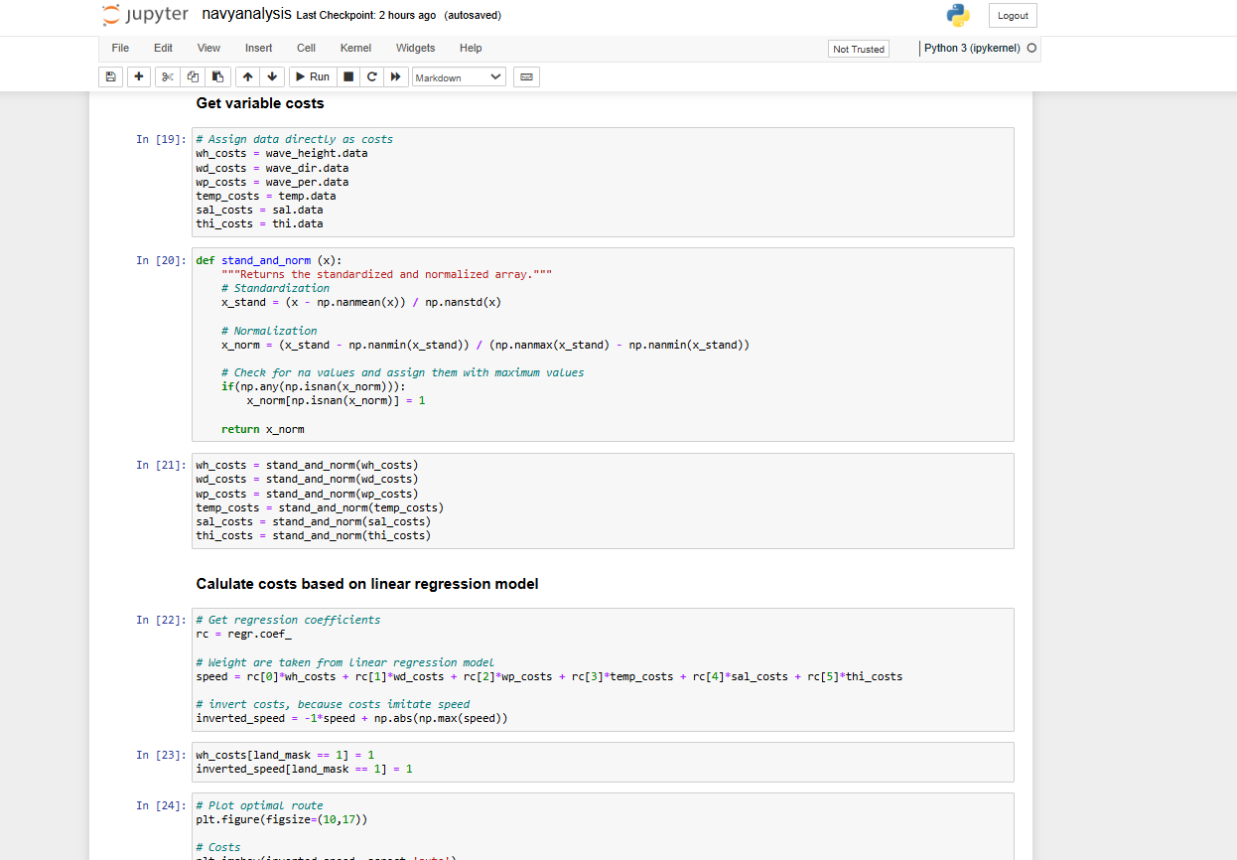
  - Getting the variable cost
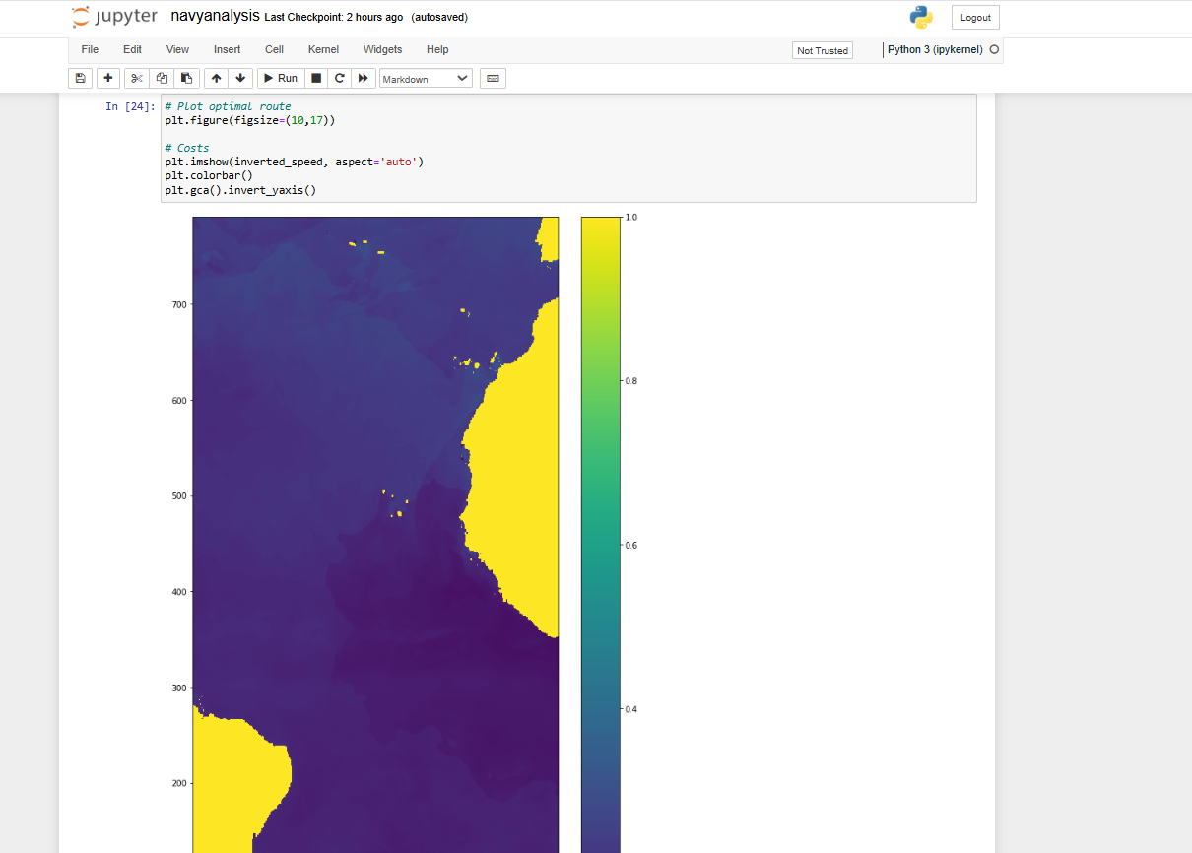
  - Plotting Optimal Route along and according to the cost
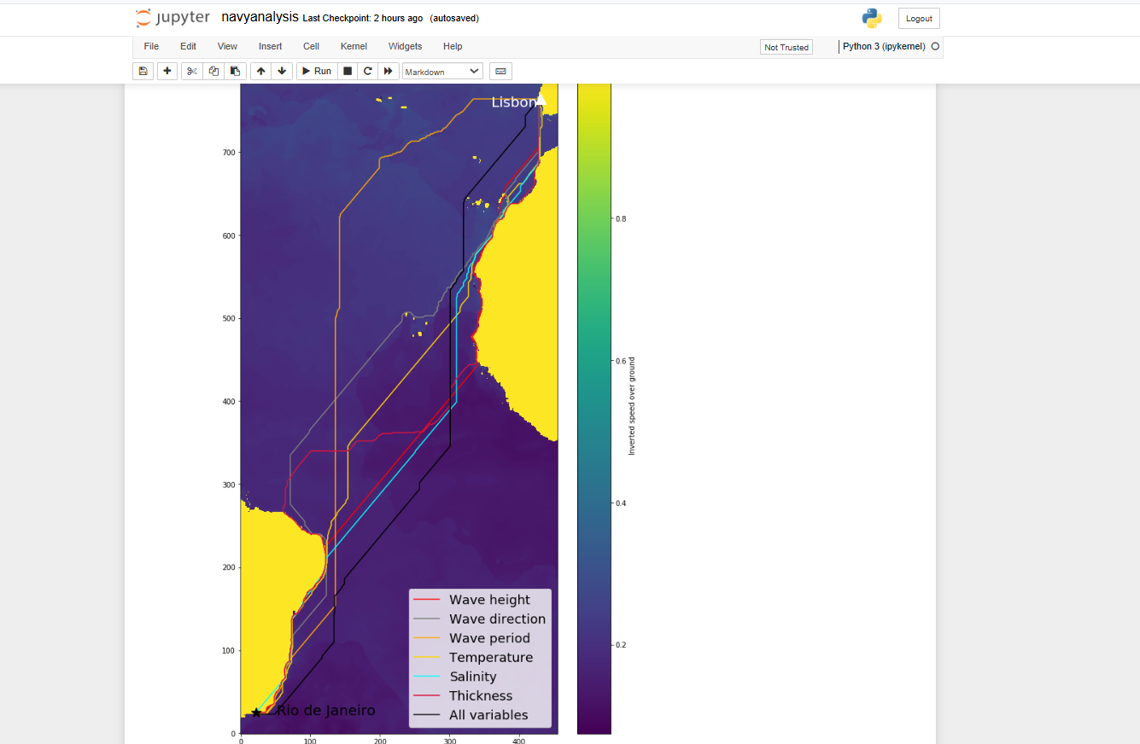
  - Plotting Optimal Routes if there is any feature creating delay
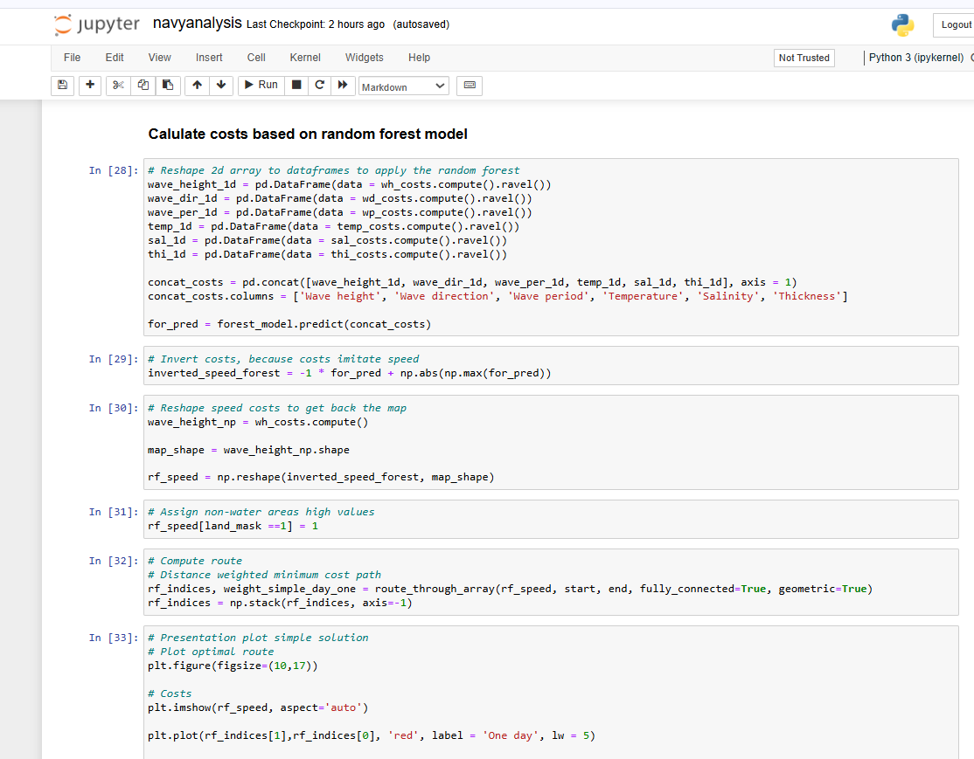
  - Cost based on Random Forest
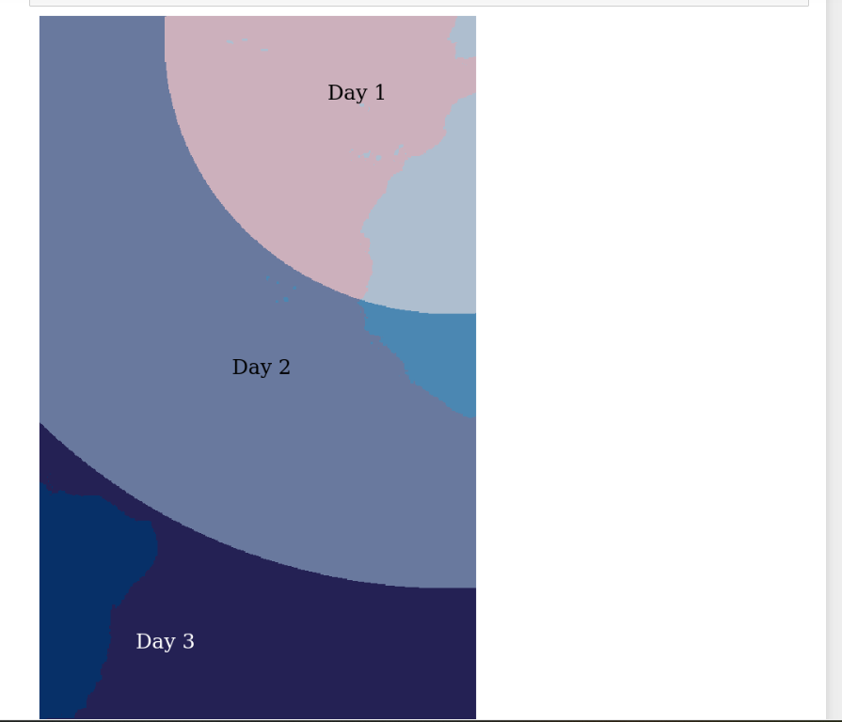
  - Showing variation in days

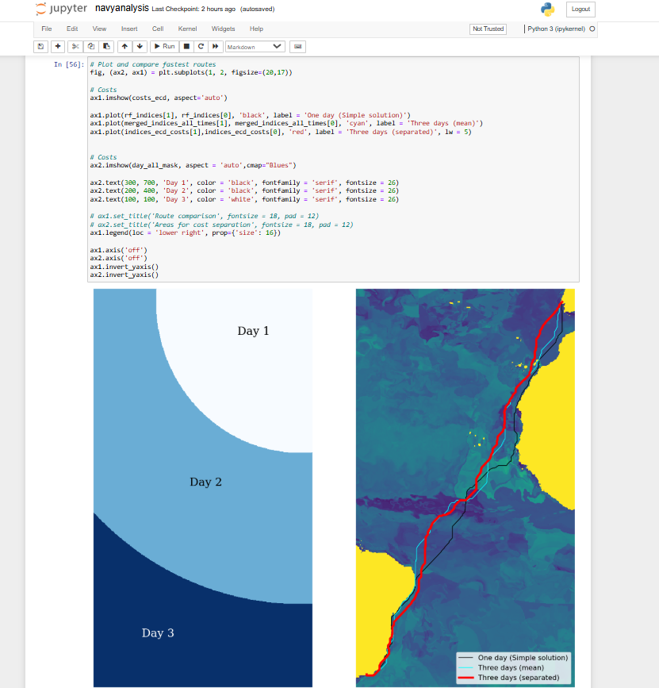
  - Comparing forest routes
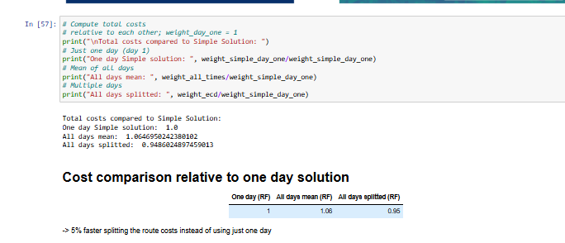
  - Cost Comparison relative to one day solution

RESULT
This project focuses on maritime route optimization between Lisbon and Rio de Janeiro using machine learning and weather forecasts to calculate optimal paths for cargo ships. The objective is to reduce operational costs while ensuring efficient and safe transit, leveraging historical environmental data such as wind speed, wave height, and pressure.
1. Dataset Summary and Preparation
The dataset contains historical marine data with features like:
- Latitude and Longitude
- Wind Speed
- Wave Height
- Date of Observation
- Pressure and other meteorological parameters
These were obtained from credible marine databases and were preprocessed to remove inconsistencies and prepare the data for machine learning models.
2. Model Building
Two models were trained to estimate the cost associated with different maritime route segments:
- Linear Regression: Used as a simple baseline model. While easy to interpret, it did not capture non-linear relationships adequately.
- Random Forest Regressor: An ensemble method that significantly improved prediction accuracy by modeling complex interactions between input features.
Result:
The Random Forest model achieved a high R² score of 0.89, indicating that it explained 89% of the variance in route cost, making it more reliable than the linear approach.
3. Routing and Cost Estimation
Simple (Single-Day) Routing
On 1st June 2021, route costs were calculated using both models. The Random Forest model predicted more realistic costs due to its ability to consider complex weather interactions. Start and destination coordinates (Lisbon and Rio) were used to trace the path and assign cost values to each segment based on predicted weather impact.
Advanced (Multi-Day) Routing
To mimic real-world shipping scenarios, forecasts across three days (June 1–3, 2021) were analyzed. The advanced solution computed mean and separated daily costs to simulate voyage variability due to changing weather patterns.
Method | Cost Estimate
One Day (RF) | Baseline cost
All Days Mean (RF) | More stable estimate
All Days Separated (RF) | Most detailed approach
The multi-day separated cost evaluation provided a nuanced view, showing that changes in conditions across days can influence cost efficiency significantly.
4. Visualization and Route Mapping
Cartopy and Matplotlib were used to:
- Plot global coastlines
- Display route paths between Lisbon and Rio
- Overlay wave and weather-related weights onto the map
The maps provided a visual representation of cost-heavy and cost-efficient zones along the oceanic route, helping identify potential detours or optimal sailing paths.
5. Key Observations
- Wave Height and Wind Speed were major factors influencing the predicted route costs.
- Random Forest handled these fluctuations much better, providing more robust estimates.
- Cost-saving routes generally avoided areas with high wave energy or unfavorable wind directions.
- Multi-day routing proved to be more realistic and actionable, considering the voyage duration of long-haul ships.

CONCLUSION
The maritime route optimization project between Lisbon and Rio de Janeiro has illustrated the powerful synergy between machine learning models and real-world environmental forecasting data. By incorporating historical marine conditions—such as wave height, wind speed, and geolocation—the project provided a data-driven approach to identifying cost-efficient and safer shipping routes across the Atlantic Ocean.
The foundation of the study rested on the development and comparison of two distinct regression models: Linear Regression and Random Forest Regressor. While the linear model served as a useful baseline, it was the Random Forest model that demonstrated superior performance with an R² score of 0.89. This high level of predictive accuracy underscored the model's ability to capture complex, nonlinear interactions between environmental features and route costs—something critical in dynamic marine environments.
Moreover, the implementation of both single-day and multi-day routing strategies allowed for comprehensive route evaluation. The single-day analysis gave an immediate estimation of route costs under fixed weather conditions, whereas the multi-day approach introduced a more realistic simulation of prolonged sea voyages. Through the comparative evaluation of average and separated costs across multiple days, it became evident that fluctuating weather can significantly affect travel efficiency and safety. This reinforced the importance of dynamic routing systems that account for changing meteorological patterns.
Visualizations using Cartopy and Matplotlib added spatial clarity to the optimization process, mapping out high-cost zones and enabling a better understanding of how natural obstacles, such as high wave zones or strong wind regions, could influence route selection. These visual components enhanced interpretability and demonstrated the practical application of data science tools in real-world scenarios.
The project also highlighted critical maritime decision-making elements, including:
- The importance of environmental variable selection,
- The need for robust machine learning techniques,
- The practicality of multi-day dynamic simulations,
- And the benefit of integrating data visualization with predictive analytics.
Ultimately, this work exemplifies how predictive modeling can significantly transform traditional marine navigation by offering safer, more economical, and environmentally conscious shipping strategies. The methodology proposed here has wide applicability—not just for intercontinental trade routes but also for domestic shipping lanes, naval operations, and offshore logistics.
Future enhancements may involve integrating real-time data via APIs, expanding the dataset to include parameters like fuel efficiency, current speed, and sea surface temperature, and deploying the model into a navigational application with user interfaces. Additionally, time series models like ARIMA or deep learning models such as LSTM could be explored to further refine multi-day forecasting capabilities.
This project serves as a practical demonstration of how data science and environmental intelligence can coalesce to solve real-world problems in logistics and transportation—providing a blueprint for modern, adaptive maritime route optimization.

REFERENCES

• Breiman, L. (2001). Random Forests. Machine Learning, 45(1), 5–32. https://doi.org/10.1023/A:1010933404324
• James, G., Witten, D., Hastie, T., & Tibshirani, R. (2013). An Introduction to Statistical Learning: With Applications in R. Springer.
• Wilks, D. S. (2011). Statistical Methods in the Atmospheric Sciences (3rd ed.). Academic Press.
• Makridakis, S., Spiliotis, E., & Assimakopoulos, V. (2018). Statistical and Machine Learning Forecasting Methods: Concerns and Ways Forward. PLOS ONE, 13(3), e0194889.
• Hyndman, R. J., & Athanasopoulos, G. (2018). Forecasting: Principles and Practice (2nd ed.). OTexts.
• Pedregosa, F., Varoquaux, G., Gramfort, A., Michel, V., Thirion, B., Grisel, O., ... & Duchesnay, É. (2011). Scikit-learn: Machine Learning in Python. Journal of Machine Learning Research, 12, 2825-2830.
• Hunter, J. D. (2007). Matplotlib: A 2D Graphics Environment. Computing in Science & Engineering, 9(3), 90–95.

GitHub Link:
https://github.com/Ashi12218604/Navy-Analysis-and-Route-Optimization

Dataset Source:
https://www.marinetraffic.com/en/ais/home/centerx:64.9/centery:19.8/zoom:5

